**VIRTUALEYE-LIFE GUARD FOR SWIMMING POOLS TO DETECT ACTIVE DROWNING**

**BATCH** : B5-5M1E

**TEAM ID** : PNT2022TMID41118

Submitted by

**TEAM LEADER** : KARTHIKA V

**TEAM MEMBER 1** : KAVIYA A

**TEAM MEMBER 2** : RAGAPRIYA M

**TEAM MEMBER 3** : GOWTHAMANI M

Problem Statement :

**Problem Statement :**

1. Swimming is one of the best exercises that helps people to reduce stress in this urban lifestyle. Swimming pools are found larger in number in hotels.
2. Applying the CNN algorithm to the dataset.Beginners, especially, often feel it difficult to breathe underwater which causes breathing trouble which in turn causes a drowning accident.

3.To overcome this conflict, a meticulous system is to be implemented along the swimming pools to save human life.

**ABSTRACT**

Safety in swimming pools is a crucial issue. Effective drowning detection methods are essential for the safety of swimmers. In this project, a novel type of drowning detection method addressing many limitations of prevailing drowning detectors is proposed. The proposed method ensures detection of drowning and reporting at the earlier stages. The proposed drowning detection method is also a generic solution that suites different water bodies from pools to oceans, and an economically method useful for both low- and middle-income countries. The prototype of the drowning detection method is developed. The results of the simulation and software are also reported in Artificial intelligence. Our method uses a HSV thresholding mechanism along with Contour detection to detect the region of interest in each frame of video sequences. The presented software can detect drowning person in indoor swimming pools and sends a voice notification to the lifeguard rescues if the previously detected person is missing for a specific amount of time. The presented algorithm for this system is tested on several video sequences in swimming pools in real conditions and the results are of high accuracy with a high capability of tracking individuals in real time. According to the evaluation results, the number of false notifications generated by the system is minimal and the maximum voice delay reported by the system is 2.6 sec which can relatively be reliable compared to the acceptable time for rescue and resuscitation.

Keywords: Drowning Detection, Contour, Color Space Analysis, Real-Time Image Processing.

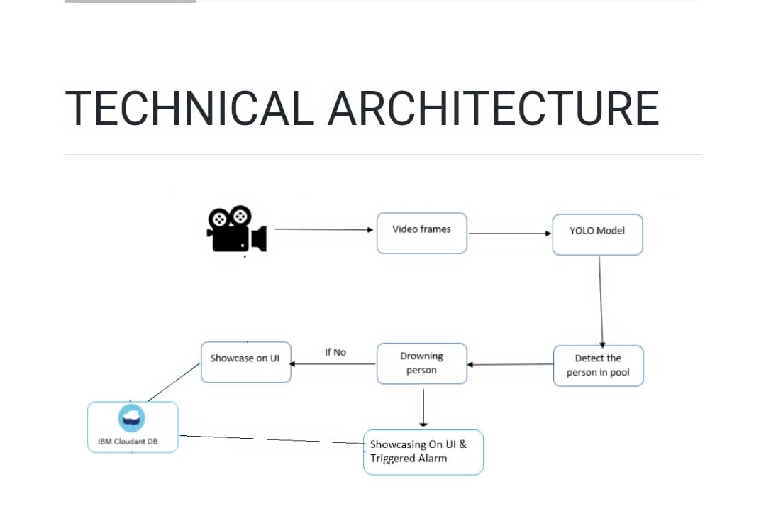

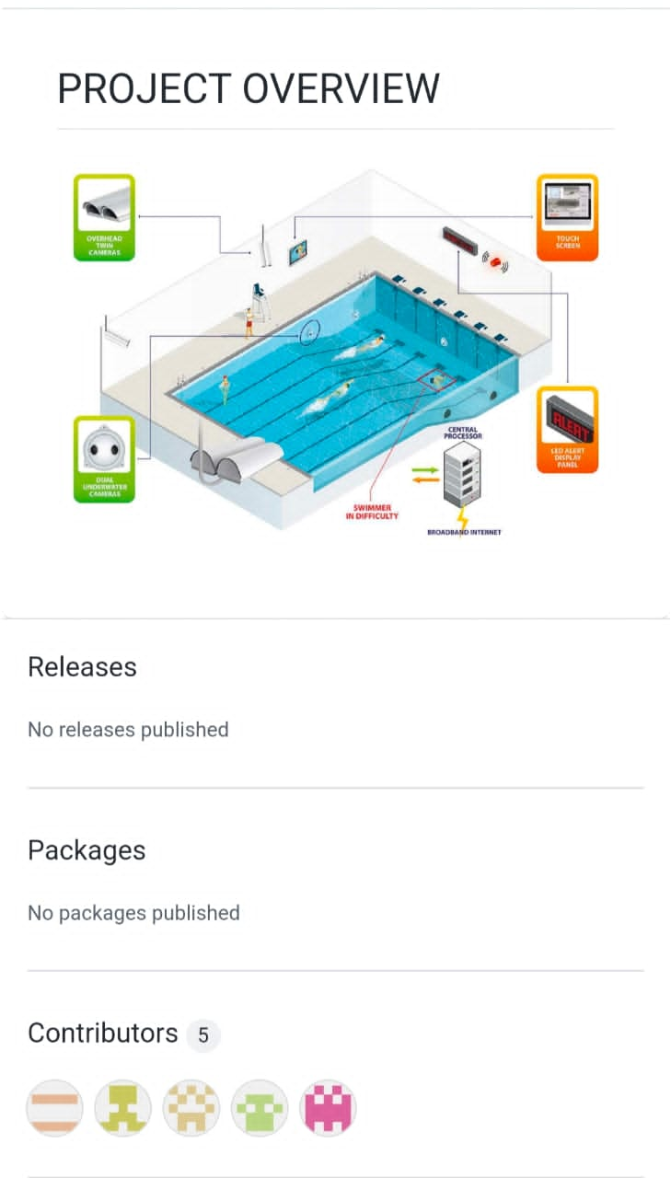

**Brainstorm:**

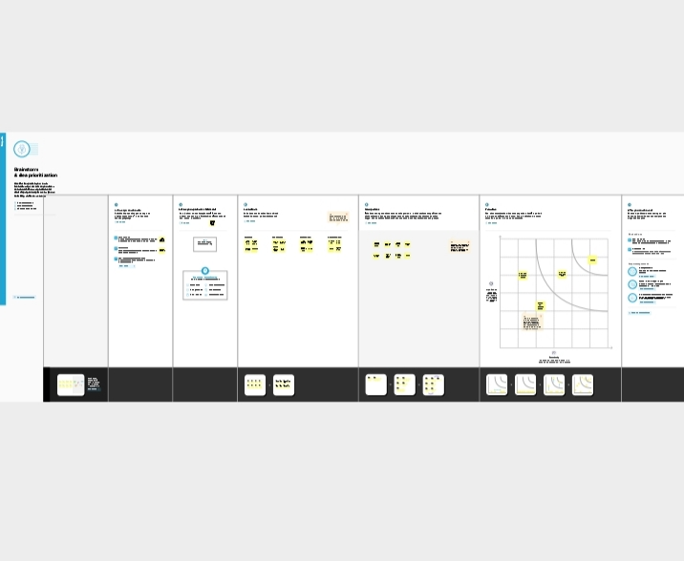

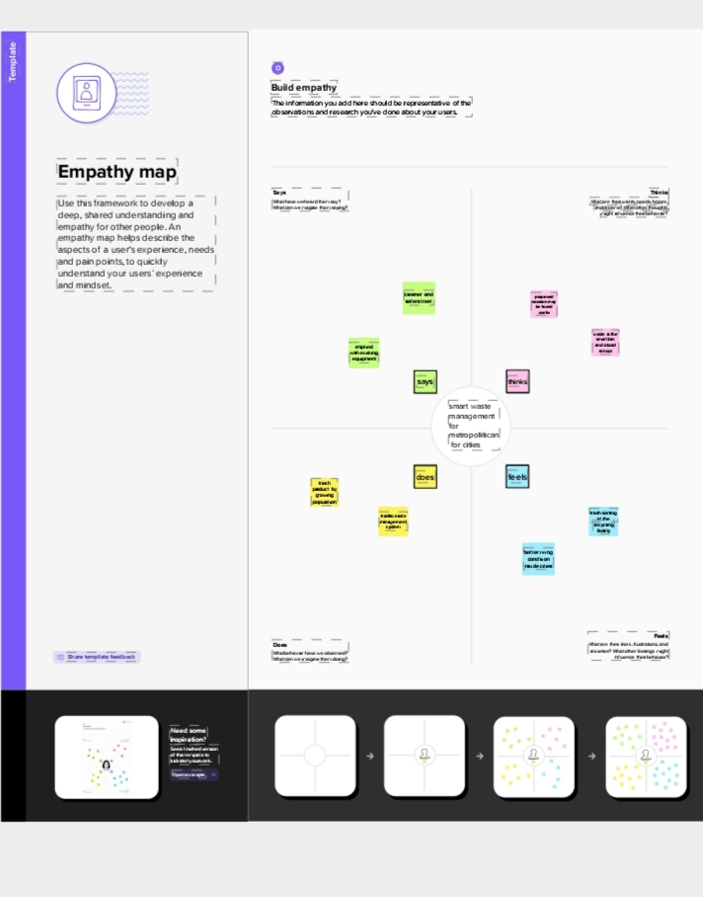**Empathy map:**

**LITERATURE REVIEW:**

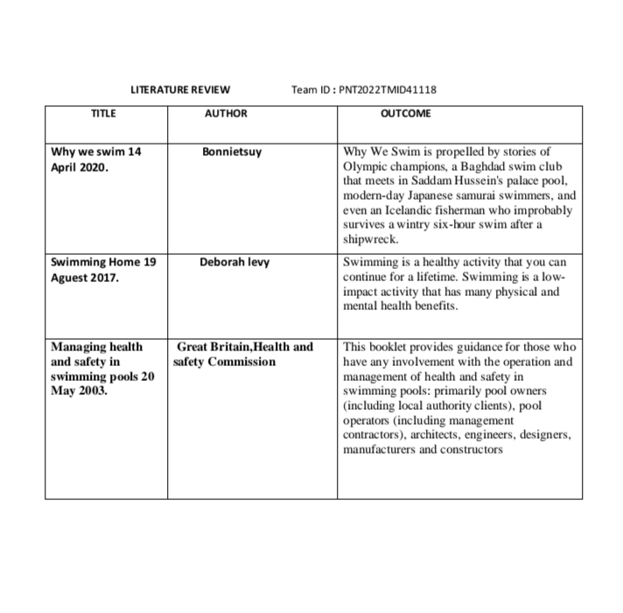

**INSTAL PYTHON PACKAGES:**



